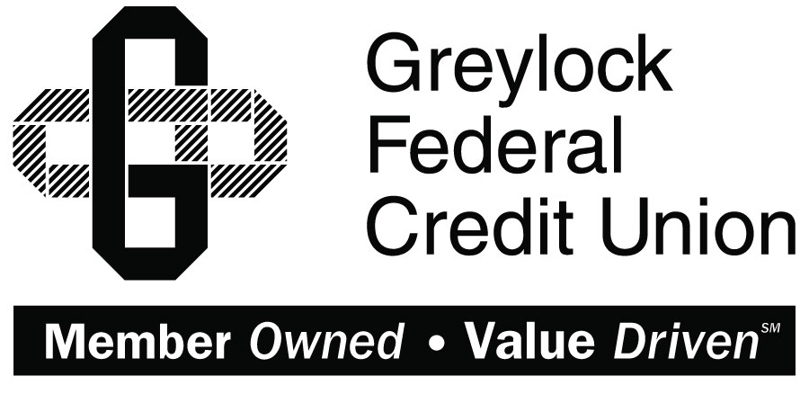

Quicken for Windows

Conversion Instructions
  - Direct Connect to Express Web Connect

Introduction
As Greylock Federal Credit Union completes its system conversion you will need to modify your Quicken settings to ensure the smooth transition of your data. Please reference the dates next to each task as this information is time sensitive.
To complete these instructions, you will need your User ID and Password for each Financial Institution.
Express Web Connect uses the same User ID and Password as Greylock Federal Credit Union’s online banking.
You should perform the following instructions exactly as described and in the order presented. If you do not, your online banking connectivity may stop functioning properly. This conversion should take 15–30 minutes.
Thank you for making these important changes!
This detour symbol indicates instructions in a Task specifically for Bill Pay within Quicken. If you do not use Quicken to make online bill payments, skip that Task.

Documentation and Procedures
- Conversion Preparation
- Backup your data file. For instructions to back up your data file, choose Help menu > Quicken Help. Search for Backup Data File and follow the instructions.
- Download the latest Quicken Update. For instructions to download an update, choose Help menu > Quicken Help. Search for Update Software and follow the instructions.
- Cancel Outstanding Payments before 10/18/2017
If you are not a Bill Pay user within Quicken, skip this Task.
This Task must be completed to avoid possible duplicate payment. If you do not cancel payments scheduled to be paid on or after 10/18/2017, these payments may still be processed.
- Choose Tools menu > Online Center.
- Select Greylock Federal Credit Union from the Financial Institution drop-down list.
- On the Payments tab, select an account from which a payment is scheduled in the future.
Click Print to save your list of pending payments. You can use this when you recreate and send these payments later.
- In the payment status list, you will cancel payments for each payee with a status that is schedule for delivery on a date on or after 10/18/2017. To do this, select the first payee and click Cancel Payment.
- Perform steps 3 & 4 for all payments scheduled for delivery on a date on or after 10/18/2017.
- On the toolbar, choose Repeating.
- Select a payment instruction and click Delete. You will need to click Delete again in a confirmation window.
- Repeat step 7 for each repeating payment instruction you have with your financial institution.
- Disconnect Accounts At Greylock Federal Credit Union on or after 10/18/2017
- Choose Tools menu > Account List.
- Click the Edit button of the account you want to deactivate.
- In the Account Details dialog, click on the Online Services tab.
- Click on Deactivate or Deactivate Online Payment (only available if you use bill pay services). Follow the prompts to confirm the deactivation.
- Click on the General tab.
- Remove the financial institution name and account number. Click OK to close the window.
- Repeat steps for each account to be disconnected.
- Reconnect Accounts to Greylock FCU on or after 10/25/2017
- Choose Tools menu > Account List.
- Click the Edit button of the account you want to activate.
- In the Account Details dialog, click the Online Services tab.
- Click Set up Now.
- Use Advanced Setup to activate your account.
- Enter Greylock FCU in the search field, select the name in the list and click Next.
- If presented with the Select Connection Method screen, select Express Web Connect.
- Enter your User ID and Password. Click Connect.
You may be presented with a security question from your Financial Institutions prior to receiving your accounts.
- Ensure you associate the account to the appropriate account already listed in Quicken. You will want to select Link to an existing account and select the matching accounts in the drop-down menu.
Do NOT select Add to Quicken unless you intend to add a new account to Quicken. If you are presented with accounts you do not want to track in this data file, select Ignore – Don’t Download into Quicken.
- After all accounts have been matched, click Next. You will receive confirmation that your accounts have been added.
- Click Done or Finish.

